# DAILY ONLINE ACTIVITIES SUMMARY

|  |  |  |  |  |  |  |  |
| --- | --- | --- | --- | --- | --- | --- | --- |
| **Date:** | **23/05/2020** | | | | **Name:** | **Sathvik R Shetty** | |
| **Sem & Sec** | **6th /B** | | | | **USN:** | **4AL17CS089** | |
| **Online Test Summary** | | | | | | | |
| **Subject** | | **PAP IA Test** | | | | | |
| **Max. Marks** | | **30** | | **Score** | | **20** | |
| **Certification Course Summary** | | | | | | | |
| **Course** | **Web Development with Python and JavaScript** | | | | | | |
| **Certificate Provider** | | | **Harvard University** | **Duration** | | | **12weeks** |
| **Coding Challenges** | | | | | | | |
| **Problem Statement:**   1. Python program to print positive numbers in a list given a list of numbers, write a Python program to print all positive numbers in given list. 2. Python program to count positive and negative numbers in a list given a list of numbers, write a Python program to count positive and negative numbers in a List. | | | | | | | |
| **Status: Completed** | | | | | | | |
| **Uploaded the report in GitHub** | | | | **Yes** | | | |
| **If yes Repository name** | | | | [https://github.com/sathvikshetty22/Online-](https://github.com/sathvikshetty22/Online-Coding) [Coding](https://github.com/sathvikshetty22/Online-Coding) | | | |
| **Uploaded the report in slack** | | | | **Yes** | | | |

**Online Test Details**

PAP TEST Details:

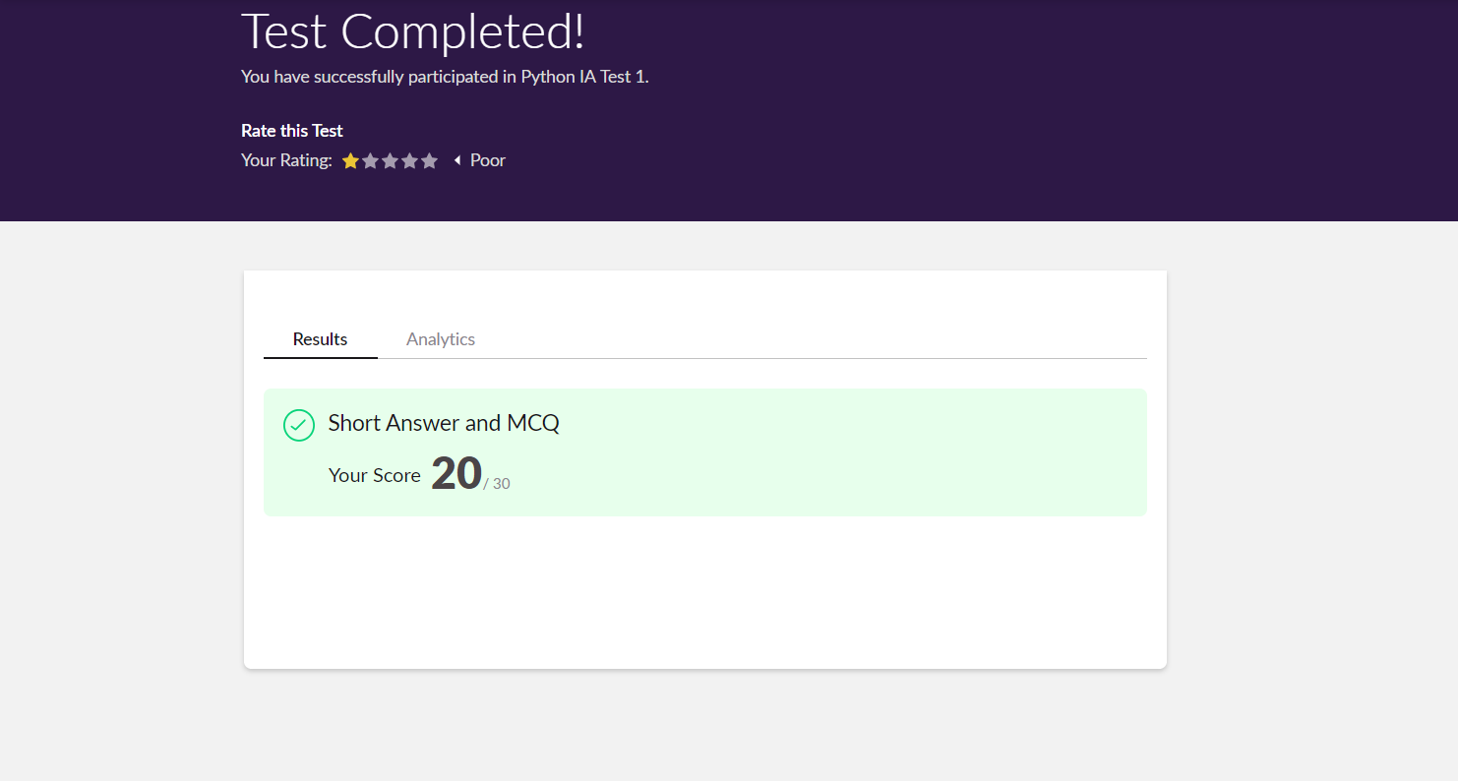

# Online Certification Details Lesson

* **JavaScript**

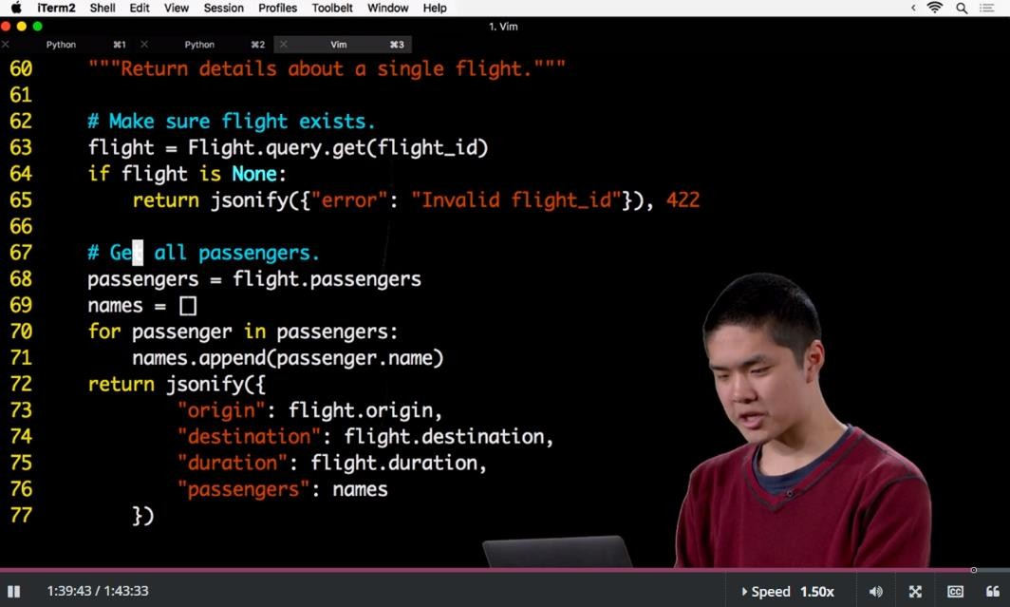

**Coding Challenge Details**

1. Python program to print positive numbers in a list given a list of numbers, write a Python program to print all positive numbers in given list.

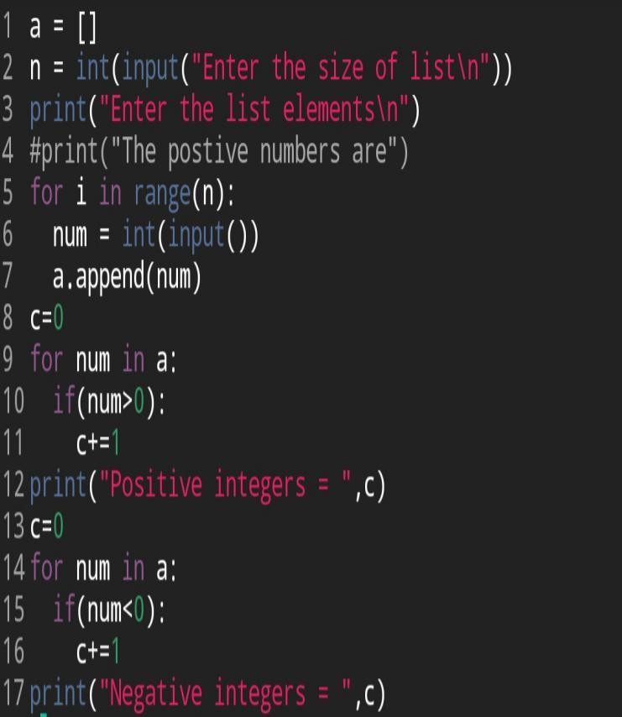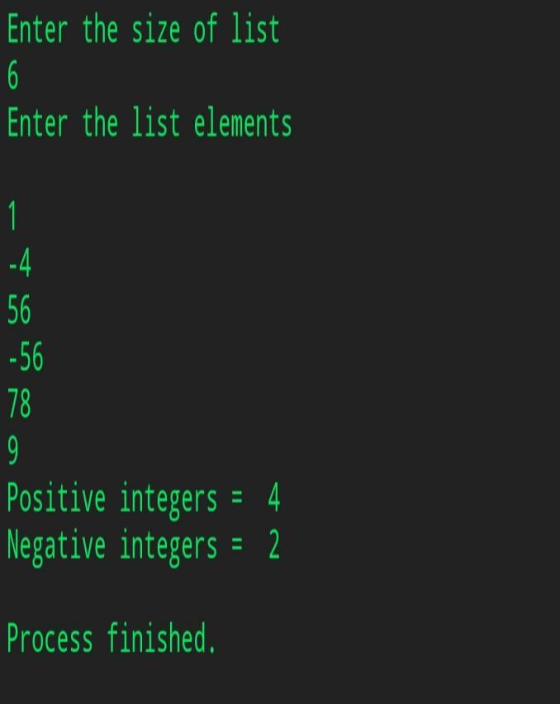

1. Python program to count positive and negative numbers in a list given a list of numbers, write a Python program to count positive and negative numbers in a List.

